视频P4〜P5：https://www.bilibili.com/video/BV18L4y1M7Bd?p=4

简单工厂模式
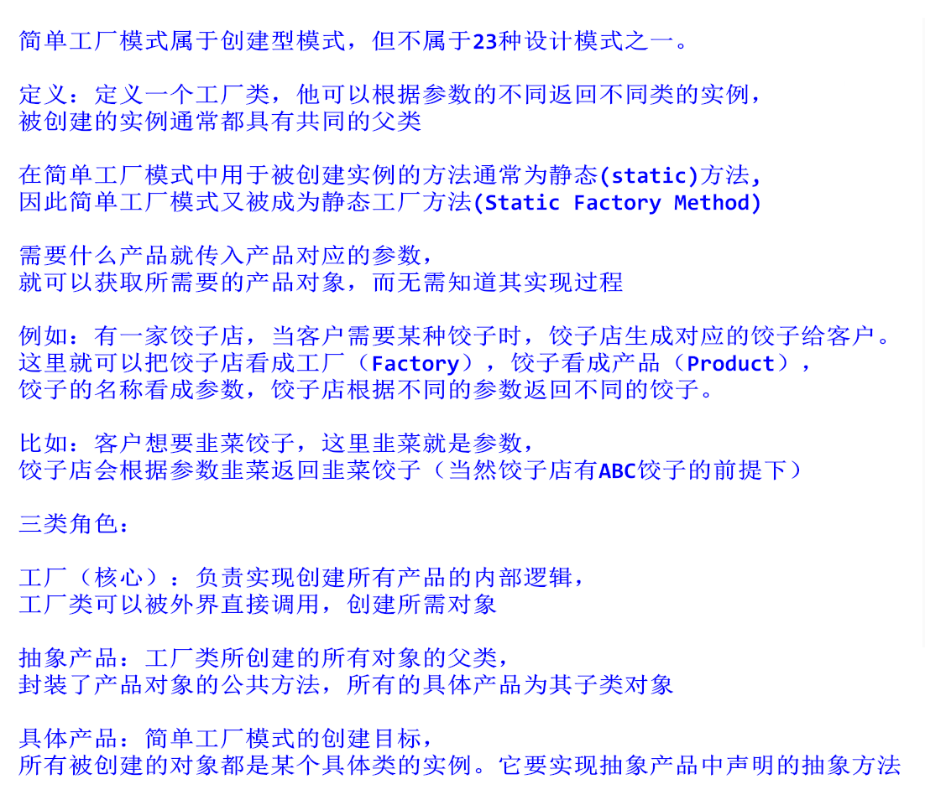

类图
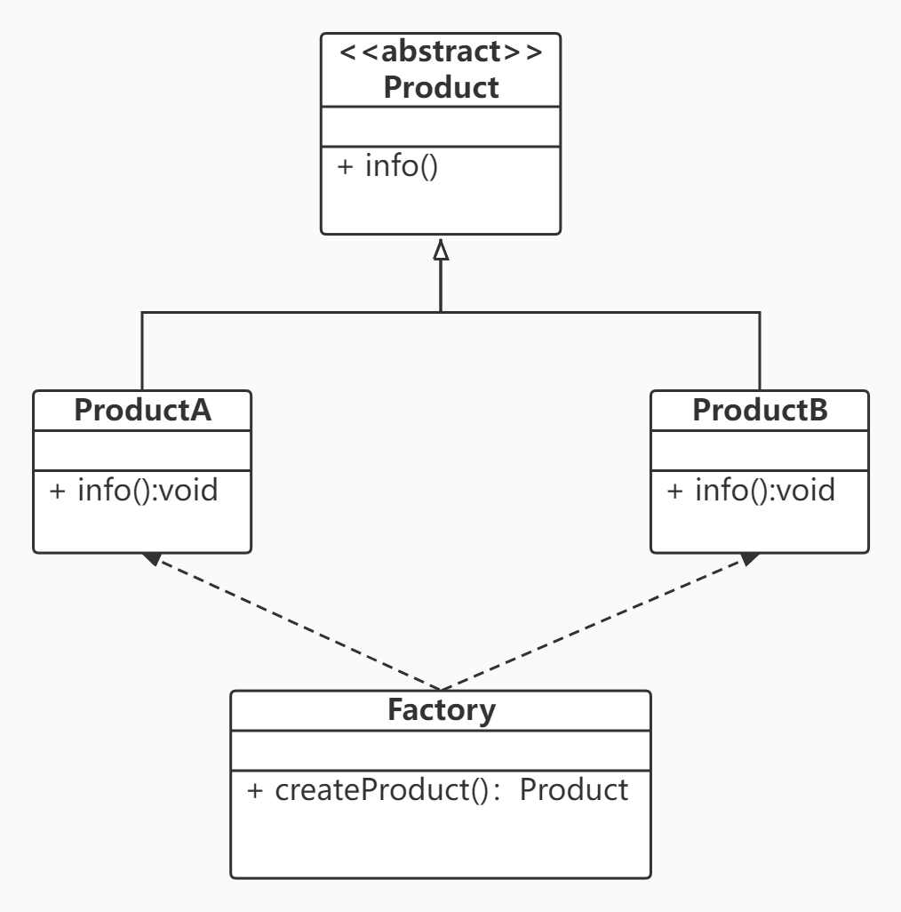

代码
public class SimpleFactory {
public static void main(String[] args) {
Product productA = Factory.createProduct("A");
productA.info();

Product productB = Factory.createProduct("B");
}
}

abstract class Product {
public abstract void info();
}

class Factory {
public static Product createProduct(String type) {
Product product = null;

switch (type) {
case "A":
product = new ProductA();
break;
case "B":
product = new ProductB();
break;
default:
System.out.println("没有 " + type + " 类型的产品！");
break;
}

return product;
}
}

class ProductA extends Product {

@Override
public void info() {
System.out.println("产品的信息：A");
}
}

class ProductB extends Product {

@Override
public void info() {
System.out.println("产品的信息：B");
}
}

