视频P55：https://www.bilibili.com/video/BV18L4y1M7Bd?p=55

备忘录模式
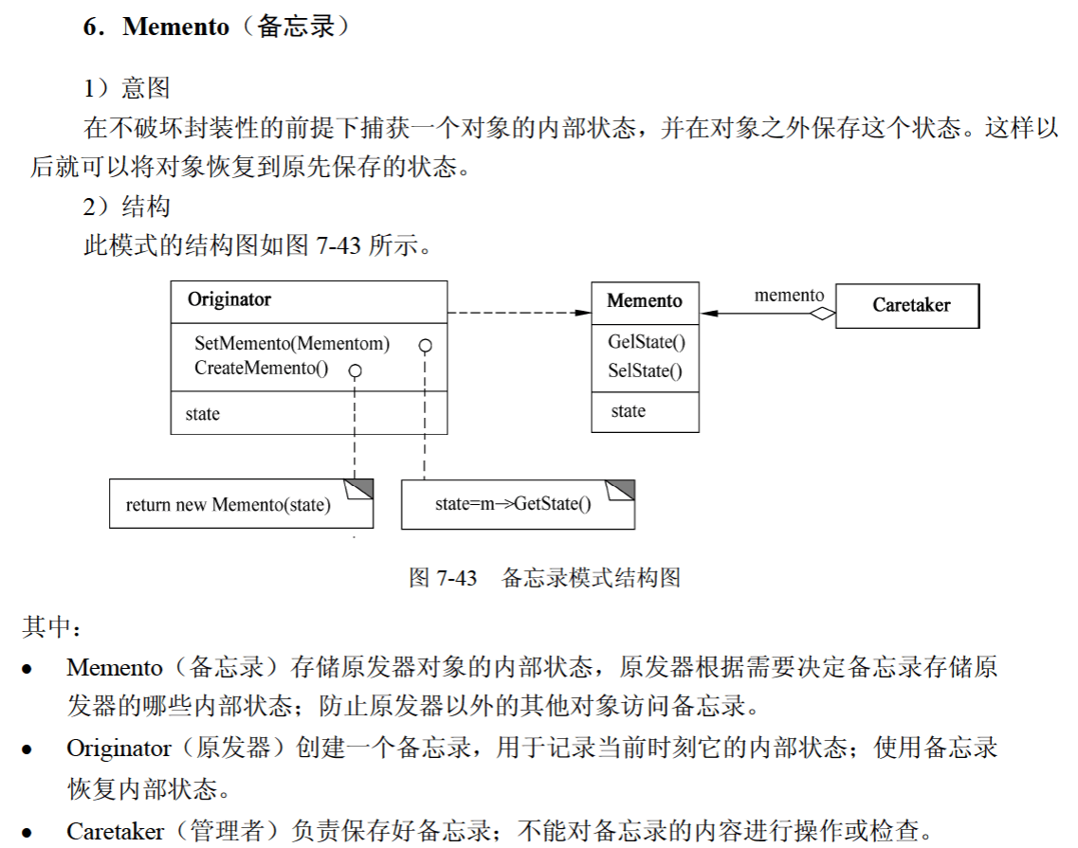
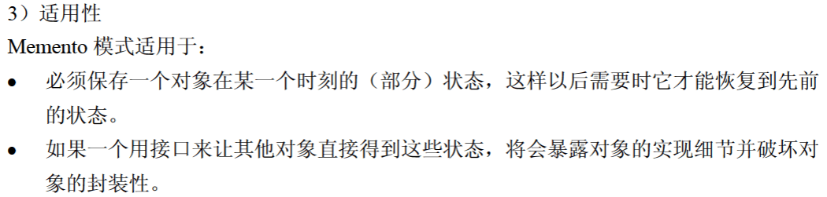

代码
import java.util.*;

public class MementoPattern {
public static void main(String[] args) {
Caretaker caretaker = new Caretaker();
Originator originator = new Originator();

originator.setState("1024");
Memento backup1 = originator.createMemento();
caretaker.addMemento(backup1);

originator.setState("2048");
Memento backup2 = originator.createMemento();
caretaker.addMemento(backup2);

originator.setState("4096");
Memento backup3 = originator.createMemento();
caretaker.addMemento(backup3);

System.out.println(originator.getState());

caretaker.showMemento();

Memento memento1 = caretaker.getMemento(2);
originator.setMemento(memento1);

System.out.println("根据第2次备份还原之后的状态为：" + originator.getState());
}
}

class Originator { // 原发器
private String state;

public void setState(String state) {
this.state = state;
}

public String getState() {
return state;
}

public Memento createMemento() {
return new Memento(state);
}

public void setMemento(Memento memento) {
state = memento.getState();
}
}

class Memento { // 备忘录
private String state;

public Memento(String state) {
this.state = state;
}

public String getState() {
return state;
}
}

class Caretaker { // 管理者
private List<Memento> mementoList = new ArrayList<>();

public void addMemento(Memento memento) {
mementoList.add(memento);
}

public Memento getMemento(int index) {
// 判断参数是否合法
if (index >= 1 && index <= mementoList.size()) {
return mementoList.get(index - 1);
}

return null;
}

public void showMemento() {
int cnt = 1;
// for (遍历对象类型 对象名 : 遍历对象)
for (Memento memento : mementoList) {
System.out.println("第" + cnt + "次备份，状态为：" + memento.getState());

cnt ++ ;
}
}
}

