2014年下半年试题六
阅读下列说明和Java代码，将应填入 （n） 处的字句写在答题纸的对应栏内。
【说明】
某灯具厂商欲生产一个灯具遥控器，该遥控器具有7个可编程的插槽，每个插槽都有开关按钮，对应着一个不同的灯。利用该遥控器能够统一控制房间中该厂商所有品牌灯具的开关，现采用Command（命令）模式实现该遥控器的软件部分。Command模式的类图如图6-1所示。
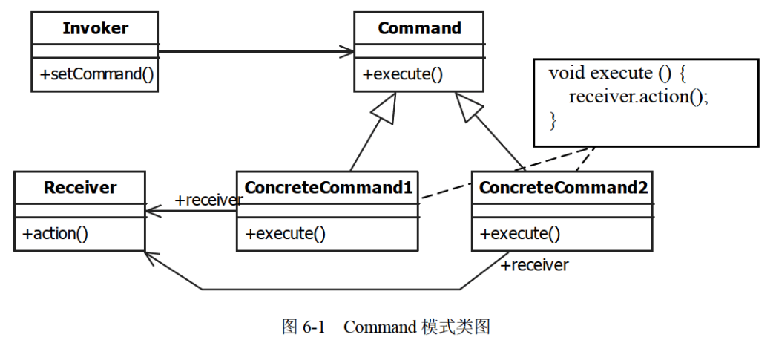

【Java代码】
class Light {
public Light() {}
public Light(String name) { /* 代码省略 */ }
public void on() { /* 代码省略 */ } // 开灯
public void off() { /* 代码省略 */ } // 关灯
// 其余代码省略
}

(1) {
public void execute();
}

class LightOnCommand implements Command { // 开灯命令
Light light;
public LightOnCommand(Light light) { this.light = light; }
public void execute() { (2) ; }
}

class LightOffCommand implements Command { // 关灯命令
Light light;
public LightOffCommand(Light light) { this.light = light; }
public void execute() { (3) ; }
}

class RemoteControl { // 遥控器
Command[] onCommands = new Command[7];
Command[] offCommands = new Command[7];
public RemoteControl() { /* 代码省略 */ }
public void setCommand(int slot, Command onCommand, Command offCommand) {
(4) = onCommand;
(5) = offCommand;
}
public void onButtonWasPushed(int slot) {
(6) ;
}
public void offButtonWasPushed(int slot) {
(7) ;
}
}

class RemoteLoader {
public static void main(String[] args) {
RemoteControl remoteControl = new RemoteControl();
Light livingRoomLight = new Light("Living Room");
Light kitchenLight = new Light("kitchen");
LightOnCommand livingRoomLightOn = new LightOnCommand(livingRoomLight);
LightOffCommand livingRoomLightOff = new LightOffCommand(livingRoomLight);
LightOnCommand kitchenLightOn = new LightOnCommand(kitchenLight);
LightOffCommand kitchenLightOff = new LightOffCommand(kitchenLight);
remoteControl.setCommand(0, livingRoomLightOn, livingRoomLightOff);
remoteControl.setCommand(1, kitchenLightOn, kitchenLightOff);
remoteControl.onButtonWasPushed(0);
remoteControl.offButtonWasPushed(0);
remoteControl.onButtonWasPushed(1);
remoteControl.offButtonWasPushed(1);
}
}

解析在下一页！

视频解析P37：https://www.bilibili.com/video/BV1XT4y1v7ih?p=37

文字解析：下方
