2017年上半年试题六
阅读下列说明和Java代码，将应填入 （n） 处的字句写在答题纸的对应栏内。
【说明】
某快餐厅主要制作并出售儿童套餐，一般包括主餐（各类比萨）、饮料和玩具，其餐品种类可能不同，但其制作过程相同。前台服务员（Waiter）调度厨师制作套餐。现采用生成器（Builder）模式实现制作过程，得到如图6-1所示的类图。
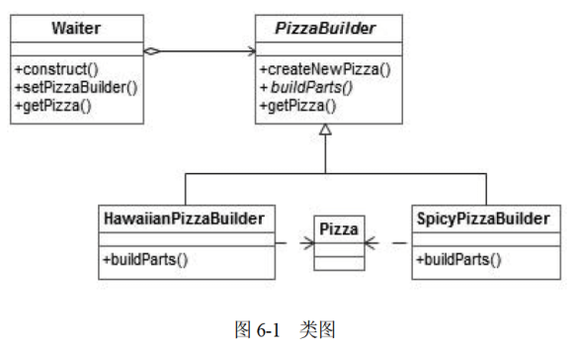

【Java代码】
class Pizza {
private String parts;
public void setParts(String parts) { this.parts = parts; }
public String toString() { return this.parts; }
}

abstract class PizzaBuilder {
protected Pizza pizza;
public Pizza getPizza() { return pizza; }
public void createNewPizza() { pizza = new Pizza(); }
public (1) ;
}

class HawaiianPizzaBuilder extends PizzaBuilder {
public void buildParts(){
pizza.setParts("cross + mild + ham&pineapp1e");
}
}

class SpicyPizzaBuilder extends PizzaBuilder {
public void buildParts() {
pizza.setParts("panbaked + hot + pepperoni&salami");
}
}

class Waiter {
private PizzaBuilder pizzaBuilder;
public void setPizzaBuilder(PizzaBuilder pizzaBuilder) {/*设置构建器*/
(2) ;
}
public Pizza getPizza() { return pizzaBuilder.getPizza(); }
public void construct() { /* 构建 */
pizzaBuilder.createNewPizza();
(3) ;
}
}
class FastFoodOrdering {
public static viod mainSting[]args) {
Waiter waiter = new Waiter();
PizzaBuilder hawaiian_pizzabuilder = new HawaiianPizzaBuilder();
(4) ;
(5) ;
System.out.println("pizza：" + waiter.getPizza());
}
}

程序的输出结果为：
pizza：cross + mild + ham&pineapple

解析在下一页！

视频解析P9〜P10：https://www.bilibili.com/video/BV1XT4y1v7ih?p=9

文字解析：下方
