2018年上半年试题六
阅读下列说明和Java代码，将应填入 （n） 处的字句写在答题纸的对应栏内。
【说明】
生成器（Builder）模式的意图是将一个复杂对象的构建与它的表示分离，使得同样的构建过程可以创建不同的表示。图6-1所示为其类图。
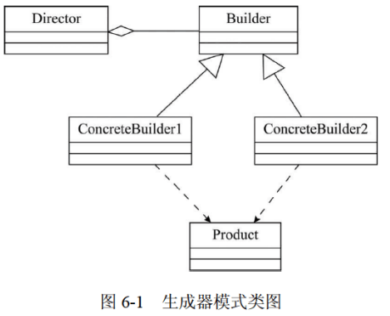

【Java代码】
import java.util.*;

class Product {
private String partA;
private String partB;
public Product() {}
public void setPartA(String s) { partA = s; }
public void setPartB(String s) { partB = s; }
}

interface Builder {
public (1) ;
public void buildPartB();
public (2) ;
}

class ConcreteBuilder1 implements Builder {
private Product product;
public ConcreteBuilder1() { product = new Product(); }
public void buildPartA() { (3) ("Component A"); }
public void buildPartB() { (4) ("Component B"); }
public Product getResult() { return product;}
}

class ConcreteBuilder2 implements Builder {
// 代码省略
}

class Director {
private Builder builder;
public Director(Builder builder) { this.builder = builder; }
public void construct() {
(5) ;
// 代码省略
}
}

class Test {
public static void main(String[] args) {
Director director1 = new Director(new ConcreteBuilder1());
director1.construct();
}
}

解析在下一页！

视频解析P11：https://www.bilibili.com/video/BV1XT4y1v7ih?p=11

文字解析：下方
