https://www.yuque.com/docs/share/cbf1854c-767f-4b8b-9dc3-a103bf730ca9#
（密码：ummx）

08:迭代生成-参考答案
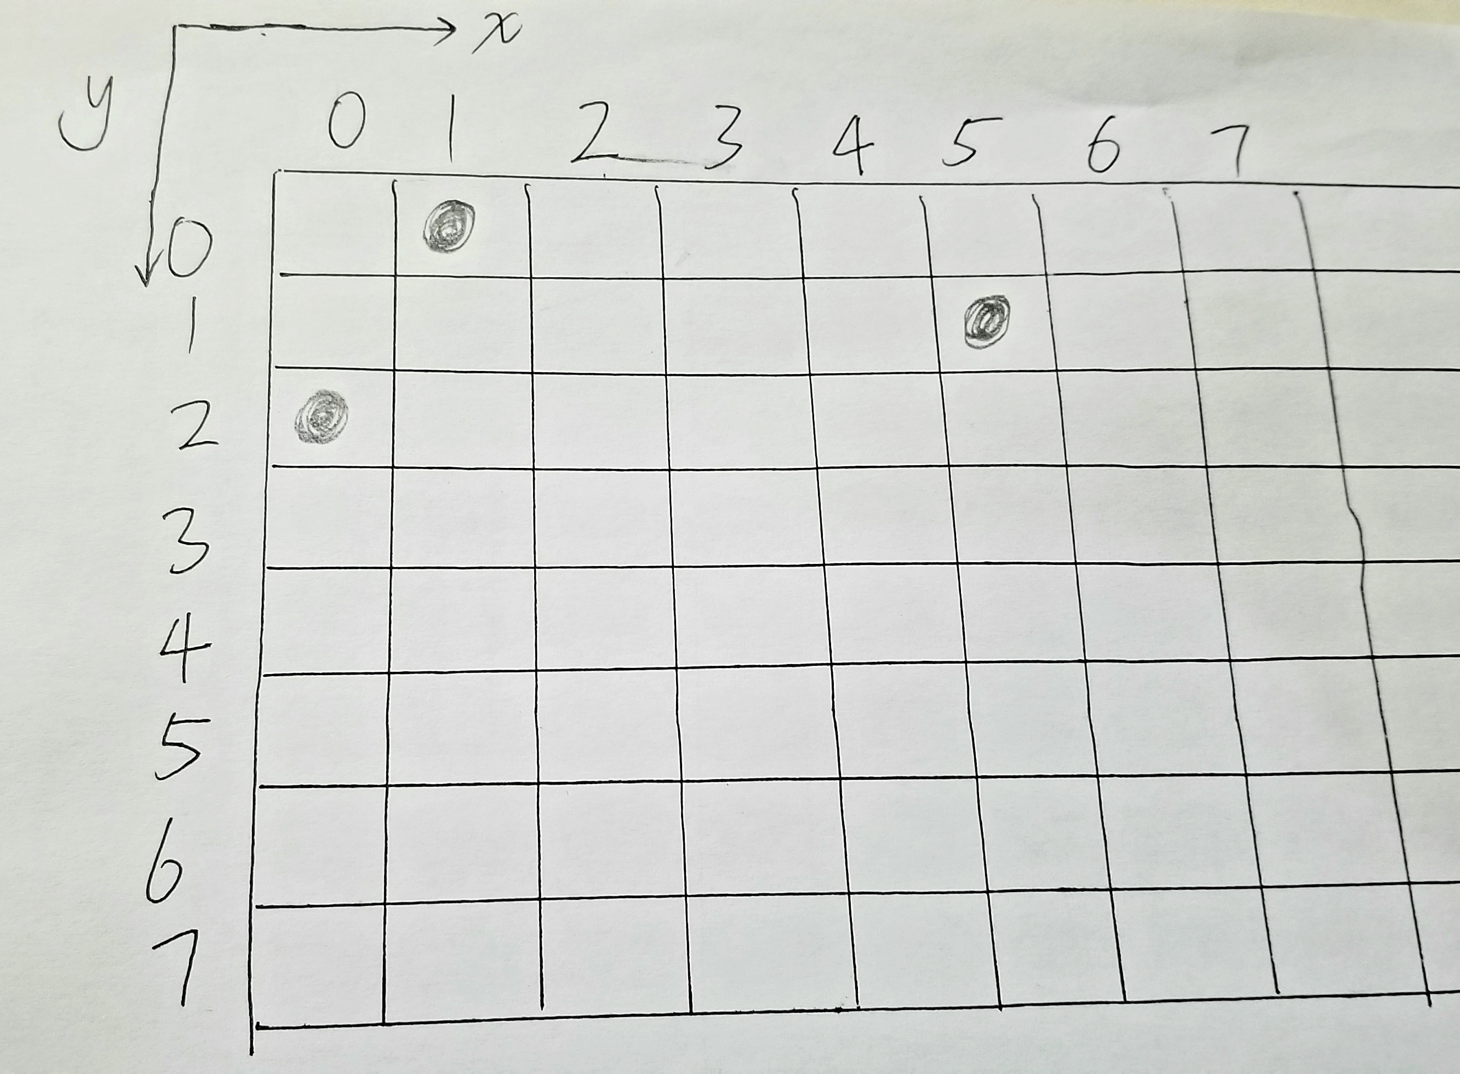

def conflict(chesses_placed, next_chess_xcor):
""" This is a conflicting function defined :param chesses_placed: use a tuple to save chesses placed :param next_chess_xcor: the x coordinate of next chess to place :return: true or false """
# get the next y coordinate by chessed placed
next_chess_ycor = len(chesses_placed)

# use next chess y coordinate to confirm the count of loop
for i in range(next_chess_ycor):

# use absolute value to confirm the same oblique line
if abs(chesses_placed[i] - next_chess_xcor) in (0, abs(i - next_chess_ycor)):
return True
return False

def place_queens(num=8, chesses_placed_tuple=()):
""" This is a placing queens function defined :param num: the count of queens :param chesses_placed_tuple: such as (1, 5, 0) :return: a generator """
for i in range(num):
if not conflict(chesses_placed_tuple, i):

# judge the last line
if len(chesses_placed_tuple) == num - 1:
yield (i,)
else:

# get one bye one element from the generator
for j in place_queens(num, chesses_placed_tuple + (i,)):
# superimpose elements to the newest tuple
yield (i,) + j

res = list(place_queens(8))print(res)print(len(res))

